# Import Package - Python Exercise

Below is the image provided along with the recreated question, terminal output, and answer:

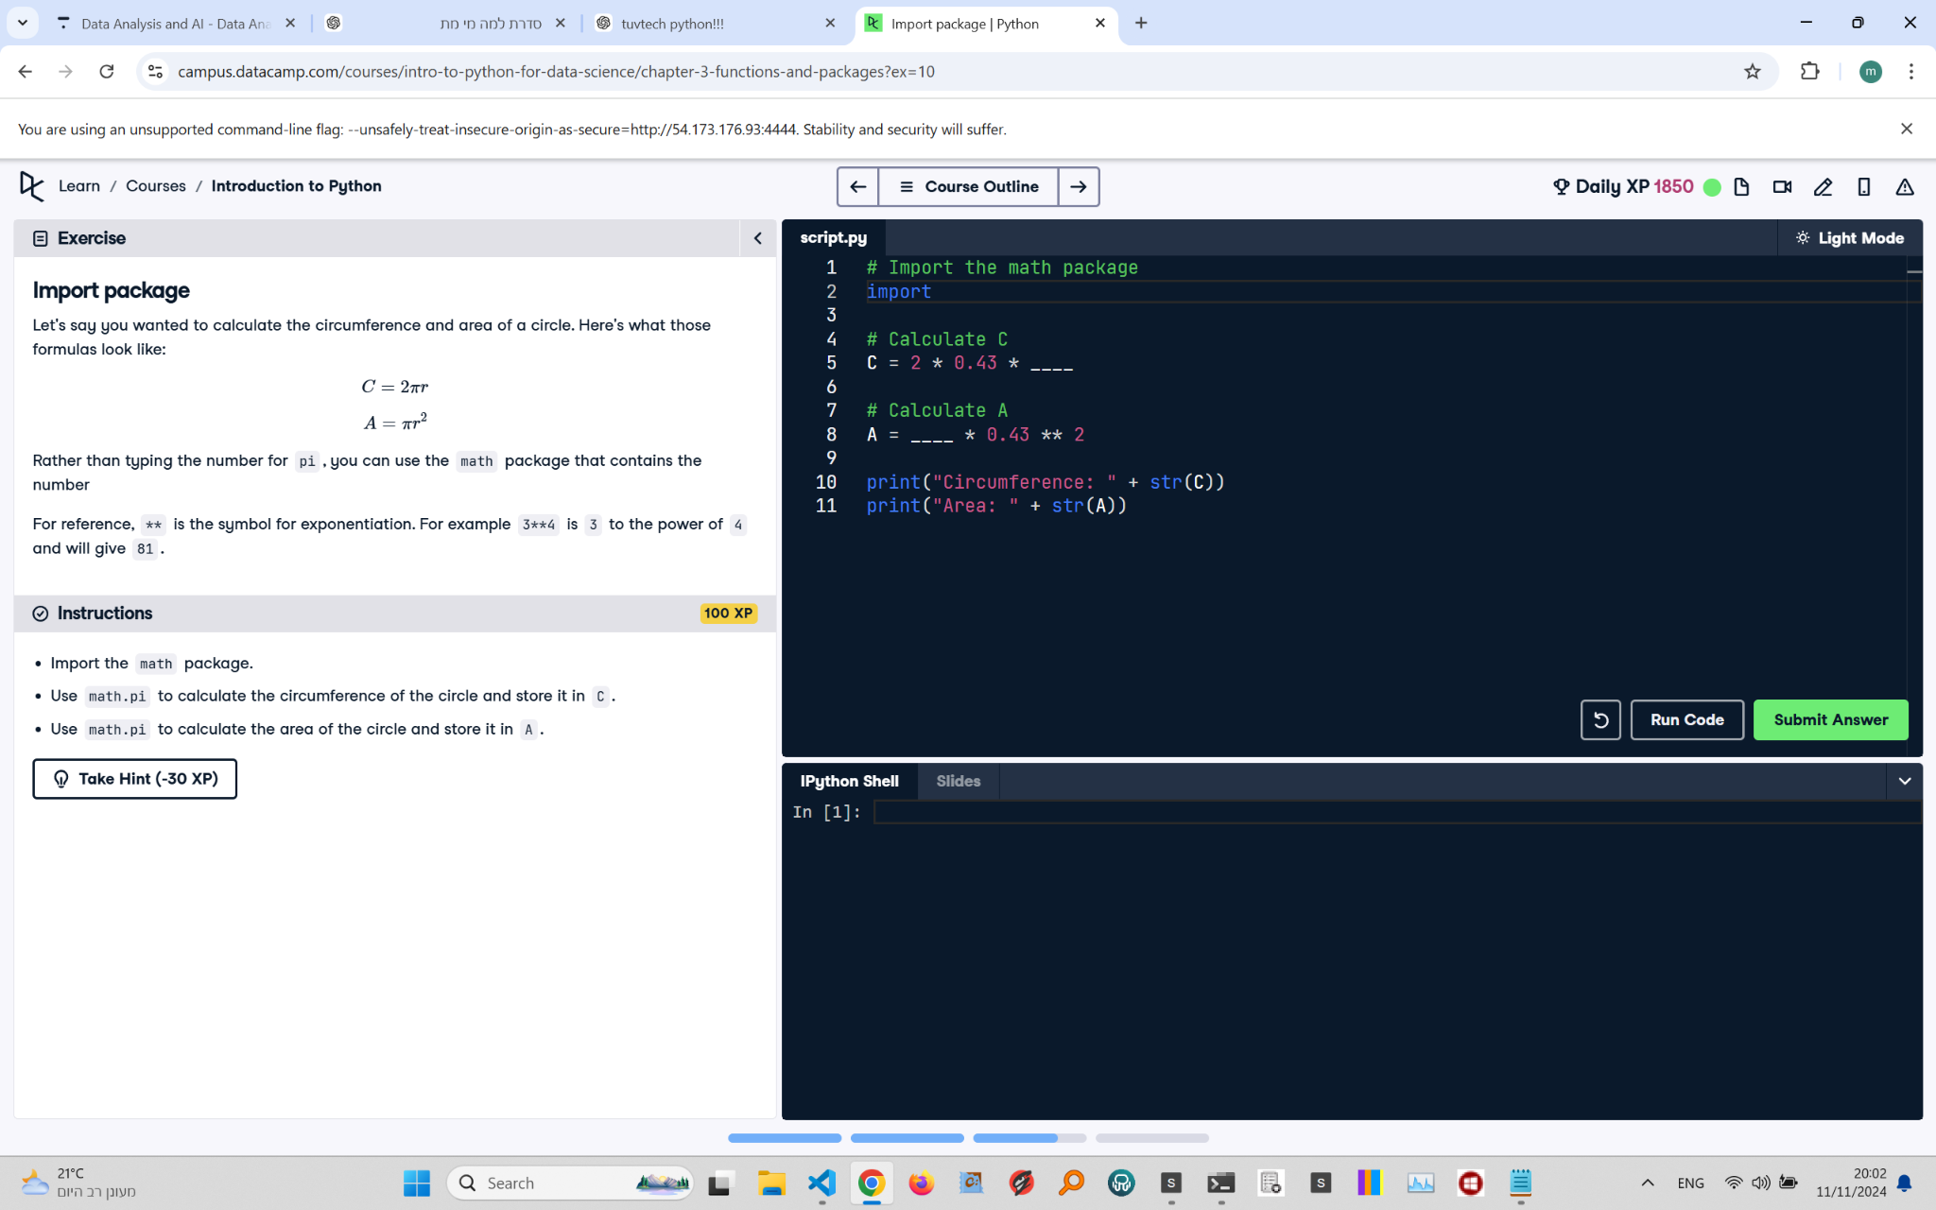

## Recreated Question and Terminal

Import Package  
Let’s say you wanted to calculate the circumference and area of a circle. Here’s what those formulas look like:

C = 2πr  
A = πr²  
  
Rather than typing the number for π, you can use the math package that contains the number.  
  
For reference, ** is the symbol for exponentiation. For example, 3**4 is 3 to the power of 4 and will give 81.

Instructions:  
- Import the math package.  
- Use math.pi to calculate the circumference of the circle and store it in C.  
- Use math.pi to calculate the area of the circle and store it in A.

## Answer

# Import the math package  
import math  
  
# Calculate C  
C = 2 * math.pi * 0.43  
  
# Calculate A  
A = math.pi * 0.43 ** 2  
  
print("Circumference: " + str(C))  
print("Area: " + str(A))

## Explanation of the Answer

The math package is imported to access the constant math.pi, representing π. The circumference is calculated using the formula 2πr, where r is 0.43. The area is calculated using πr², with r raised to the power of 2. The results are printed using the print() function.